Module 8 Network Access

* **Beginner Question**

1. **Explain Switch**

* A network switch connects devices in a network to each other, enabling them to talk by exchanging data packets. Switches can be hardware devices that manage physical networks or software-based virtual devices. A network switch operates on the data-link layer, or Layer 2, of the Open Systems Interconnection (OSI) model.

1. **Explain Switch Boot Sequence**

* It tests the CPU, DRAM, and the portion of the flash device that makes up the flash file system. Next, the switch loads the boot loader software. The boot loader is a small program stored in ROM and is run immediately after POST successfully completes.

1. **Explain Three Methods to access Switch Command Line Interface**

* The Cisco Inner Operating System, the IOS has three command line modes, User EXEC mode, or user mode, Privileged EXEC mode, or privileged mode, and then the Global Configuration mode.

1. **Explain and Configuring the Cisco Internet Operating System**

* The Cisco IOS is a proprietary kernel that provides routing, switching, internetworking, and telecommunications features. The first IOS was written by William Yeager in 1985 and enabled networked applications.

**5. Explain Switch Port**

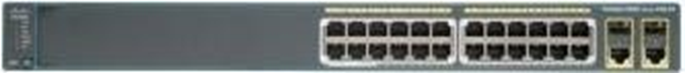

* It accepts physical connectors from computers and other network devices and then uses packet switching to receive and forward data. Connecting different devices to the ports on a network switch allows them to communicate with one another via data transfer within the switch.

1. **Configure Basic Password Settings on a switch**

* Done.

1. **Configure Line Password Settings on a switch**

* Done.

1. **Configure Password Settings on a switch**

* Done.

1. **Configure IPv4 on a switch**

* Done.

1. **Verifying IPv4 on a switch**

* Done.

1. **Explain Basic VLAN**

* A virtual local area network (VLAN) is a virtualized connection that connects multiple devices and network nodes from different LANs into one logical network.

1. **Explain VTP**

* VLAN Trunk Protocol (VTP) reduces administration in a switched network. When you configure a new VLAN on one VTP server, the VLAN is distributed through all switches in the domain. This reduces the need to configure the same VLAN everywhere.

1. **Explain CDP.**

* A customer data platform (CDP) is designed for marketing. It collects and unifies first-party customer data from multiple sources to build a single, coherent, complete view of each customer. It then makes that data available to marketers to create targeted and personalized marketing campaigns.

1. **Identifying VLAN**

* Done.

1. **Describe the basic operation of STP**

* Spanning Tree Protocol (STP) is a Layer 2 network protocol used to prevent looping within a network topology. STP was created to avoid the problems that arise when computers exchange data on a local area network (LAN) that contains redundant paths.

1. **Explain IPv4 subnetting.**

* Each IP class is equipped with its own default subnet mask which bounds that IP class to have prefixed number of Networks and prefixed number of Hosts per network. Classful IP addressing does not provide any flexibility of having less number of Hosts per Network or more Networks per IP Class.

1. **What is subnet mask?**

* A subnetwork or subnet is a logical subdivision of an IP network. The practice of dividing a network into two or more networks is called subnetting. Computers that belong to the same subnet are addressed with an identical group of its most-significant bits of their IP addresses.

1. **Explain binary decimal hexadecimal with example**

* Base 10 (Decimal) — Represent any number using 10 digits [0–9] Base 2 (Binary) — Represent any number using 2 digits [0–1] Base 8 (Octal) — Represent any number using 8 digits [0–7] Base 16(Hexadecimal) — Represent any number using 10 digits and 6 characters [0–9, A, B, C, D, E, F]

1. **Describe the Need for Public IPv4 and Private IP Addressing**

* A public IP address identifies you to the wider internet so that all the information you're searching for can find you. A private IP address is used within a private network to connect securely to other devices within that same network.

1. **Explain Subnet Prefix**

* Subnet masks (IPv4) and prefixes (IPv6) identify the range of IP addresses that make up a subnet, or group of IP addresses on the same network. For example, a subnet can be used to identify all the machines in a building, department, geographic location, or on the same local area network (LAN).

1. **Explain How to Connect Router with Switch**

* Connect an ethernet cable to one of the ports at the back of the switch, then connect the other end to one of the ethernet ports at the back of the router.

1. **Explain Routing Basics with command**

* 10.1. 1 — Basic Router Configuration Steps

1. Router(config)# hostname hostname.
2. Router(config)# enable secret password.
3. Router(config)# line console 0.
4. Router(config-line)# line vty 0 4.
5. Router(config-line)# exit.
6. Router(config)# banner motd delimiter message delimiter.
7. Router(config)# end.
8. Router> enable.

**23.Configuration basic IP address in fig.**

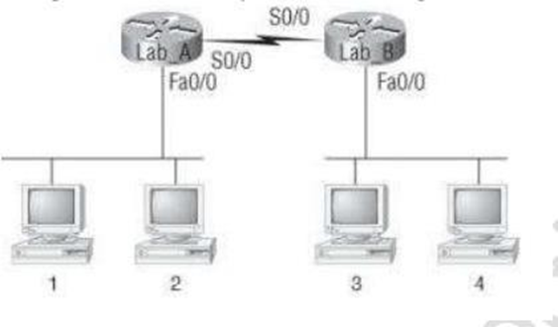

* Done.

**24. Create Static Routes**

* Done.

**25. Verifying IP Routing**

* Done.

**26. Explain EIGRP**

* Enhanced Interior Gateway Routing Protocol (EIGRP) is a network protocol that enables routers to exchange information more efficiently than earlier network protocols, such as Interior Gateway Routing Protocol (IGRP) or Border Gateway Protocol (BGP).

**27. Explain OSPF Basics**

* OSPF is an Interior Gateway Protocol (IGP). In an OSPF network, routers or systems within the same area maintain an identical link-state database that describes the topology of the area.

**28. Explain OSPF Area**

* An OSPF network can be divided into sub-domains called areas. An area is a logical collection of OSPF networks, routers, and links that have the same area identification. A router within an area must maintain a topological database for the area to which it belongs.

**29. Explain DR/BDR Selection**

* Router is highest OSPF priority will become DR and router with second-highest priority will become BDR. If the priority of the routers are same then, the router with the highest Router ID is selected as DR and the router with second-highest Router ID is selected as BDR.

**30. Explain OSPF**

* The OSPF (Open Shortest Path First) protocol is one of a family of IP Routing protocols, and is an Interior Gateway Protocol (IGP) for the Internet, used to distribute IP routing information throughout a single Autonomous System (AS) in an IP network.

**31. Explain Describe IPv6 addresses**

* An IPv6 address is 128 bits in length and consists of eight, 16-bit fields, with each field bounded by a colon. Each field must contain a hexadecimal number, in contrast to the dotted-decimal notation of IPv4 addresses.

**32. What is 6to4 tunnel?**

* 6to4 tunnels enable isolated IPv6 sites to communicate across an automatic tunnel over an IPv4 network that does not support IPv6. To use 6to4 tunnels, you must first configure a boundary router on your IPv6 network as one endpoint of the 6to4 automatic tunnel.

**33. Explain Wireless Technology**

* Wireless technology is tech that allows people to communicate or data to be transferred from one point to another without using cables or wires. A lot of the communication is done with radio frequency and infrared waves.

**34. Explain Basic Wireless Devices**

* A wireless device has some sort of network connectivity. A cell phone is wireless, and a laptop or PDA would be wireless if they had a wireless modem. Similarly, applications are wireless when they connect and exchange data with a network.

**35. Explain Wireless Security**

* Wireless network security primarily protects a wireless network from unauthorized and malicious access attempts. Typically, wireless network security is delivered through wireless devices (usually a wireless router/switch) that encrypts and secures all wireless communication by default.

**36. Explain WPA or WPA2 Pre-Shared Key**

* One way to secure your Wi-Fi network is by using a Wi-Fi Protected Access Pre-Shared Key (WPA-PSK). WPA-PSK is a security protocol that provides secure wireless access to Wi-Fi networks. It is a type of authentication that requires a pre-shared key (password) to access the network.
* **Intermediate Question**

1. **Explain Logging into a Switch**

* Log in to a Network Switch via Telnet

1. Connect the management port of the switch to the RJ45 port of the PC with an Ethernet cable like Cat5e and Cat6 cables.
2. Power on the PC.
3. Type the username and password (admin/admin) in the login interface, then move on to the configuration menu as shown below.
4. **Explain Switch User Mode, Enable (Privileged) Mode and Global Configuration Mode**

* User Mode allows to enable mode, display the data, and the users, and can perform certain networking tasks. Privileged Mode allows to display, modify and also delete the information and can change the features also.

1. **Gathering Switch Basic information**

* Done.

1. **Explain SSH**

* The Secure Shell Protocol is a cryptographic network protocol for operating network services securely over an unsecured network. Its most notable applications are remote login and command-line execution. SSH applications are based on a client–server architecture, connecting an SSH client instance with an SSH server.

1. **Configure SSH Setting On a Switch**

* Done.

1. **Explain Telnet Setting**

* The TELNET protocol is based upon the notion of a virtual teletype, employing a 7-bit ASCII character set. The primary function of a User TELNET, then, is to provide the means by which its users can 'hit' all the keys on that virtual teletype. Essentially, it used an 8-bit channel to exchange 7-bit ASCII data.

1. **Verifying Switch Interface Status**

* Done.

1. **Configure VLAN**

* Done.

1. **Verifying VLAN**

* Done.

1. **Configure VLAN Trucking**

* Done.

1. **Give Reasons for Using VLANs**

* VLANs provide a number of advantages including ease of administration, confinement of broadcast domains, reduced network traffic, and enforcement of security policies. VLANs enable logical grouping of end-stations that are physically dispersed on a network.

1. **Static VLANs**

* A static VLAN is a group of ports designated by the switch as belonging to the same broadcast domain. That is, all ports carrying traffic for a particular subnet address would belong to the same VLAN. Using a VLAN, you can group users by logical function instead of physical location.

1. **Dynamic VLANs**

* Dynamic VLAN assignment separates and isolates devices into different network segments based on the device or user authorization and their characteristics. The flow of traffic between those VLANs is governed by a firewall or another routing device which can then enforce specific network access rules.

1. **Brief explain STP Timer**

* There are several STP timers, as this list shows: hello — The hello time is the time between each bridge protocol data unit (BPDU) that is sent on a port. This time is equal to 2 seconds (sec) by default, but you can tune the time to be between 1 and 10 seconds.

1. **Explain how Switches Calculate Their Root Cost**

* Switches send BPDUs, which include the root path cost. This is the cost of the path from the sending switch to the root bridge. It is calculated by adding the individual port costs along the path from the switch to the root bridge.

**16.Configure STP on Switch**

* Done.

**17.Verifying STP on a Switch**

* Done.

**18.What is Port Security how to find Port with command?**

* To configure port security, three steps are required:

1. define the interface as an access interface by using the switchport mode access interface subcommand.
2. enable port security by using the switchport port-security interface subcommand.

**19. Classified Default subnet mask for Class A, B, C, D**

* The classification is shown with the help of the below table and figure.

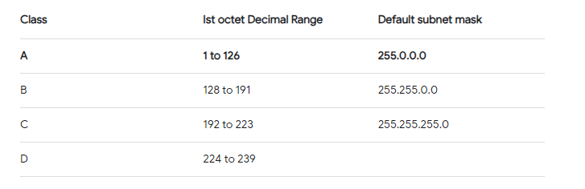

**20. Explain Classless Inter-Domain Routing**

* Classless Inter-Domain Routing (CIDR or supernetting) is a way to combine several class-C address ranges into a single network or route. This method of routing adds class-C Internet Protocol (IP) addresses. These addresses are given out by Internet Service Providers (ISPs) for use by their customers.

1. **How to define subnetting address of class A, B, C**

* Network classes

1. Class A networks use a default subnet mask of 255.0.0.0 and have 0-127 as their first octet.
2. Class B networks use a default subnet mask of 255.255.0.0 and have 128-191 as their first octet.
3. Class C networks use a default subnet mask of 255.255.255.0 and have 192-223 as their first octet.
4. **Explain Classless and Class full Addressing**

* If you haven't, the main difference between classful and classless addressing is in the subnet length: classful addressing uses fixed-length subnet masks, but classless uses variable length subnet masks (VLSM).

1. **Details of VLSM (variable length Subnet Mask**

* VLSM stands for Variable Length Subnet Mask where the subnet design uses more than one mask in the same network which means more than one mask is used for different subnets of a single class A, B, C or a network. It is used to increase the usability of subnets as they can be of variable size.

1. **Explain Static Routing**

* Static routing is a form of routing that occurs when a router uses a manually-configured routing entry, rather than information from dynamic routing traffic.

1. **Explain Default Routing**

* This is the method where the router is configured to send all packets toward a single router (next hop). It doesn't matter to which network the packet belongs, it is forwarded out to the router which is configured for default routing. It is generally used with stub routers.

1. **Configuring IP routing**

* Done.

1. **Configure VLAN Routing**

* Done.

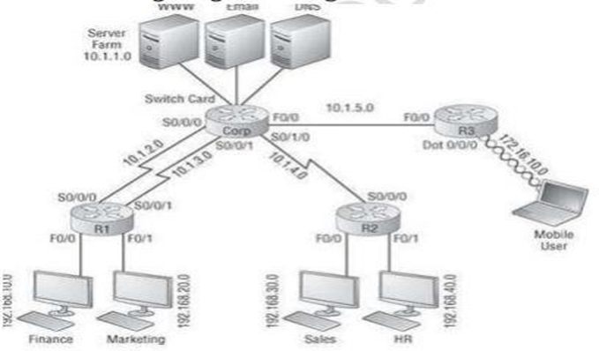

1. **Routing Protocol Metric**

* Routing metrics are the values or criteria that routing protocols use to compare and select the best routes among multiple options. Different routing protocols use different metrics, such as hop count, bandwidth, delay, cost, reliability, and load.

1. **Explain how OSPF calculates the cost for a route**

* The Cost formula is reference bandwidth divided by interface bandwidth. The default reference bandwidth of 100 Mbps is used for OSPF cost calculation. For example, if we have an Ethernet interface (10 Mbps), the OSPF path cost value is 100 Mbps / 10 Mbps = 10.

1. **Define Benefits and Uses of IPv6**

* IPv6 enables the increased use of summary routes and hierarchical routing. IPv6 fragmentation and reassembly are handled by the sender and receiver, not routers on the path, making routing even more efficient. Instead of broadcasting to all nodes on a Layer 2 domain, multicast is used.

1. **Define this IPV6 Address**

* An Internet Protocol Version 6 address is a numeric label that is used to identify and locate a network interface of a computer or a network node participating in a computer network using IPv6. IP addresses are included in the packet header to indicate the source and the destination of each packet.

1. **Explain IPv6 Routing Protocols**

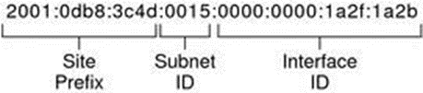

* Routing in IPv6 is almost identical to IPv4 routing under CIDR. The only difference is the addresses are 128-bit IPv6 addresses instead of 32-bit IPv4 addresses. With very straightforward extensions, all of IPv4's routing algorithms, such as OSPF, RIP, IDRP, IS-IS, can be used to route IPv6.

1. **Explain Wireless Access Points**

* In computer networking, a wireless access point, or more generally just access point, is a networking hardware device that allows other Wi-Fi devices to connect to a wired network.

1. **Define IEEE 802.11 Transmissions**

* IEEE 802.11 is used in most home and office networks to allow laptops, printers, smartphones, and other devices to communicate with each other and access the Internet without connecting wires.

1. **Explain Independent Basic Service Set (Ad Hoc)**

* Independent Basic Service Set (IBSS), as the name suggests, is a service set that allows wireless devices or stations to communicate with each other without any medium or central device. It does not contain or include any AP (Access Point). That's why it is also known as an ad hoc mode or peer to peer network.

1. **Explain How to Secure Wireless Network**
2. Change default passwords. ...
3. Restrict access. ...
4. Encrypt the data on your network. ...
5. Protect your Service Set Identifier (SSID). ...
6. Install a firewall. ...
7. Maintain antivirus software. ...
8. Use file sharing with caution. ...
9. Keep your access point software patched and up to date.

* **Advance question**

1. **Setting administrative factions**

* Done.

1. **Setting hostnames**

* Done.

1. **Setting banners**

* Done.

1. **Setting passwords**

* Done.

1. **Viewing, saving, and erasing configurations**

* Done.

1. **Configure an IP address on a switch**

* Done.

1. **Configuring SSH**

* Done.

1. **Configuring Telnet**

* Done.

1. **Explain Layer 3 Switch**

* A Layer 3 switch is basically a switch that can perform routing functions in addition to switching. A client computer requires a default gateway for layer 3 connectivity to remote subnets.

1. **Describe Dynamic IP configuration with DHCP**

* The assignment of IP addresses happens dynamically within a given address range. As a result, a device connected to the network doesn't have a forever address. The IP address can periodically change as its lease time expires unless the lease is successfully renewed.

1. **Explain 802.1q Protocol**

* 802.1Q is the networking standard that defines virtual LANs (VLANs) on an Ethernet network. VLANs are logical networks that share a single physical connection using 802.1Q tagged frames. An Ethernet frame can contain an 802.1Q tag, with fields that specify VLAN membership and user priority.

1. **Explain the Switch Port Mode Command**

* Using the “Switchport mode access” command forces the port to be an access port while and any device plugged into this port will only be able to communicate with other devices that are in the same VLAN. Using the “Switchport mode trunk” command forces the port to be trunk port.

1. **Explain the Removing Command of VLAN**

* Remove the VLAN by performing one of the following steps:

1. To delete the VLAN temporarily, use the -t option as follows: # dladm delete-vlan -t vlan.
2. To make the deletion persist, perform the following: Remove the VLAN. # dladm delete-vlan vlan. Remove the /etc/hostname. vlan-interface file.
3. **Describe Inter VLAN Routing**

* Inter-VLAN routing is the ability to route, or send, traffic between VLANs that are normally blocked by default. Switches and VLANs work at the MAC address Layer (Layer 2). Traffic can't be routed between VLANs at Layer 2 based on MAC addresses.

1. **Explain Dynamic Routing**

* Dynamic routing, also called adaptive routing, is a process where a router can forward data via a different route for a given destination based on the current conditions of the communication circuits within a system.

1. **Explain routing loop**

* A routing loop is an issue that occurs when the routers forward packets such that the same single packet ends up back at the same router repeatedly in the network because of the unusual behavior of the routing table when the data packets keep getting routed again and again between two or more routers.

1. **Configure and verify inter switch connectivity**

* Done.

1. **Configure and Verify VLAN Trucking**

* Done.

1. **Explain and configure PAGP**

* PAgP can be configured on a Cisco switch to operate in three different modes: auto - passive negotiation of the channel. desirable - active negotiation of the channel. on - no protocols are used: it assumes the other side has enabled link aggregation.

1. **Configuring Ether Channel**

* Done.

1. **Verifying Ether Channel**

* Done.

1. **Explain PAGP and LACP**

* Both LACP and PAGP packets are exchanged between switches over Etherchannel capable ports. The most significant difference is the vendors supported for them. LACP is open standard and supported by most of vendors, while PAGP is Cisco proprietary only used between Cisco devices.

1. **Configure and Verifying IPv4 Addressing and Subnetting**

* Done.

1. **Explain the Network Address and Broadcast Address**

* In every network, the first and the last IP addresses are not assigned to any host. The first IP address is called the network address and the last IP address is called the broadcast address.

1. **Explain Classful Network**

* A classful network is an obsolete network addressing architecture used in the Internet from 1981 until the introduction of Classless Inter-Domain Routing (CIDR) in 1993. The method divides the IP address space for Internet Protocol version 4 (IPv4) into five address classes based on the leading four address bits.

1. **Practice Example #5B: 255.255.255.0 (/24)**

* Done.

1. **Practice Example #2A: 255.255.240.0 (/20)**

* Done.

1. **Given the no of hosts as 126, 50, 20 and 5 Find IP address and subnet mask using class (192.168.1.0)**

* Done.

**29. Explain this Network**

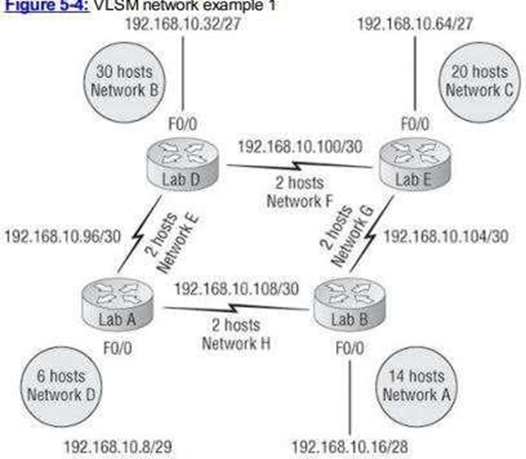

* VLSM stands for Variable Length Subnet Mask where the subnet design uses more than one mask in the same network which means more than one mask is used for different subnets of a single class A, B, C or a network. It is used to increase the usability of subnets as they can be of variable size.

**30. Put right addressing in fig.**

* 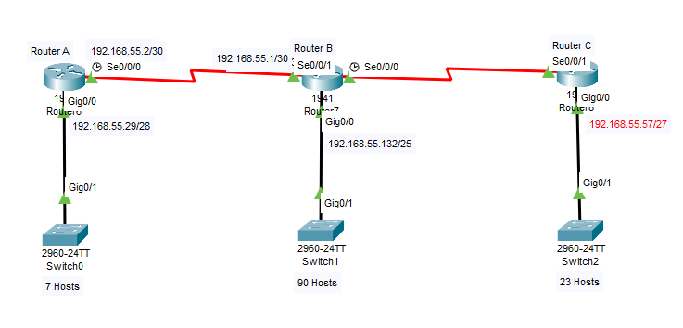

**31. Explain Routed and Routable Protocol**

* A routed protocol can be used by all hosts on the internetwork. On the other hand, a routing protocol is only employed when routers are involved. Its goal is to assist routers in creating and maintaining routing tables. Examples include IP and IPX.

**32. Explain IGP**

* An interior gateway protocol (IGP) is a dynamic route update protocol used between routers that run on TCP/IP hosts within a single autonomous system. The routers use this protocol to exchange information about IP routes.

**33. Explain Distance Vector, link state and Hydride**

* It is a dynamic routing algorithm in which each router shares knowledge of its neighbors with every other router in the network.

**34. Explain and Verifying OSPFv2**

* Open Shortest Path First Version 2 (OSPFv2) is a link-state routing protocol that uses link-state advertisements (LSAs) to update neighboring routers about a router's interfaces. Each router maintains an identical area-topology database to determine the shortest path to any neighboring router.

**35. Explain Wildcard Mask**

* A wildcard mask is a mask of bits that indicates which parts of an IP address are available for examination. In the Cisco IOS, they are used in several places, for example: To indicate the size of a network or subnet for some routing protocols, such as OSPF.

**36. Explain Address Types and Special Addresses**

* Four levels of addresses are used in an internet employing the TCP/IP protocols: physical address, logical address, port address, and application-specific address. Each address is related to a one layer in the TCP/IP architecture, as shown in the following Figure.

1. **Configuring Cisco Routers with IPv6**

* Done.

1. **Explain RIPng, EIGRPv6, OSPFv3**

* RIP Stands For Routing Information protocol. EIGRP Stands For Enhanced Interior Gateway Routing protocol. IGRP Stands For Interior Gateway Routing protocol. OSPF stands For Open shortest path First.

**39. Creating a 6to4 tunnel**

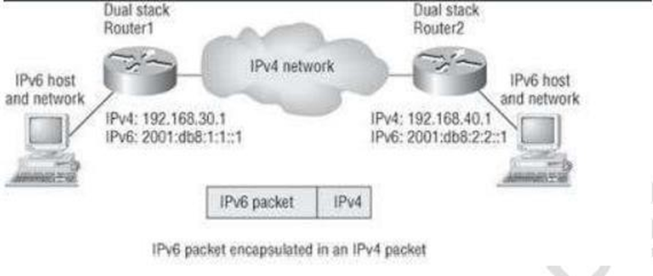

* Done.

1. **Explain 802.11 Committees and subcommittees**

* The Institute of Electrical and Electronics Engineers (IEEE) 802 Committee (from here on, "802 Commitee") is the organization that develops and maintains standards for the physical and data-link layers of transmission media for wired and wireless networks.

1. **Explain Wireless Topologies**

* The topology of a wireless network is simply the way network components are arranged. It describes both the physical layout of devices, routers, and gateways, and the paths that data follows between them.